KJSCE/IT/TY B Tech/SEMVI/SM/2021-22

Experiment No. 6

Title: Single channel Queuing system
(Using Extend Sim)

(Autonomous College Affiliated to University of Mumbai)
KJSCE/IT/TY B Tech/SEMVI/SM/2021-22

Batch: A4

Roll No.: 1914078

Experiment No.: 6

Aim: To Implement the single channel Queuing model using Extend Sim and estimate system
performance
.

___________________________________________________________________________
Resources needed: Extend Sim 7

___________________________________________________________________________
Theory

Problem Statement:

Cars arrive at the service centre approximately every 4mins where cars are washed. There is only one route to the car wash. It takes 6mins to wash a car.

Model the problem as a queuing system.

Animate the model in 2D.

Run the simulation for 8 hrs.

Plot and verify the following results

- Length of the queue against the time spend in system.

- Number of cars washed

To reduce the queue length, add a second bay.

Run the simulations for 8 hrs and plot the results.

Concepts:

A basic Discrete Event Model

The most common Discrete Event Model involves the handling of one or more waiting lines or queues, such as those found in supermarkets or factories.

The key to discrete event modelling is the construction of flow diagram using blocks to represent the operations and resources. The

Conceptual Model assumptions:

The Car wash model represents a business operation where cars are washed.

The assumptions for the model are:

- The model runs for 8hrs.
- Arrival of the customer is constant (every 4mins).
- Service times is specified as 6 minutes.
- The blocks come from the Item, Value, and Plotter libraries
___________________________________________________________________________

(Autonomous College Affiliated to University of Mumbai)

KJSCE/IT/TY B Tech/SEMVI/SM/2021-22

Procedure / Approach /Algorithm / Activity Diagram:

Steps:
Starting a model and setting simulation parameters

The following steps are typical when starting any discrete event model.
- Open a new model worksheet

- Give the command Run > Simulation Setup. In the Setup tab enter the simulation parameters:
✓

  - Global time units: seconds
  - End time 480
- If they aren’t already open, open the Item, Plotter, and Value libraries

- Place an Executive block (Item library) on the top left corner of the model worksheet

- Open dialog of the Executive block ; control tab; select options;

  - Stop Simulation: when simulation end time is 8hrs.

***********************

The Executive block does event scheduling and manages discrete event simulations. It must be present in every discrete event model. All other blocks to the right of the executive block.

Start small

In building any simulation model, it is easiest to start with a simple subset of the process and add detail until you arrive at a completed model that approximates the system that’s being modelled. This allows you to test at various stages while making the model building process more manageable.

The following table lists the blocks that will be added to the worksheet and their use in the model.

Except for the Plotter block from the Plotter library and random number block from value library, the blocks in the table are from the Item library.

_____________________________________________________________

Name (Label)

Block Function

Create block (customers)

Generates items or values, either randomly or on schedule. If used to generate items, it pushes them into the simulation and should be followed by a queue-type block.

Purpose in Carwash Model

Generates cars that arrive as per process defined

(Autonomous College Affiliated to University of Mumbai)

KJSCE/IT/TY B Tech/SEMVI/SM/2021-22

Queue block(Entry Line)

Acts as a sorted queue or as a resource pool queue. As a sorted queue, holds items in FIFO or LIFO order, or sorts items based on their attribute or priority.

Purpose in Carwash Model

Holds the cars and, when the wash bay is available, releases one by one in first-in, first-out order.

Activity block(Server)

Processes one or more items simultaneously. Processing time is a constant or is based on a distribution or an item’s attribute.

Purpose in Carwash Model

Washes the cars for a simulated 6 mins

Exit (Exit)

Removes items from the simulation and counts them as they leave.

Purpose in Carwash Model

Removes the cars from the model.

Plotter, Discrete Event

Purpose in Jobshop Model

Reports the length of the waiting line and how many cars have been washed.
___________________________________________________________________________

- Starting at the right of the Executive block, place the blocks on the model worksheet in a line from left to right, based on their order in the table.
- Label the blocks as the system entities.

Enter the dialog parameters and settings for each block

Make the connections

Run the simulation

Verify the results

Animate the model

___________________________________________________________________________

Results: (Program printout with output)

(Autonomous College Affiliated to University of Mumbai)

KJSCE/IT/TY B Tech/SEMVI/SM/2021-22

Program: (Printed model developed in Extend Sim)
Graph with one counter
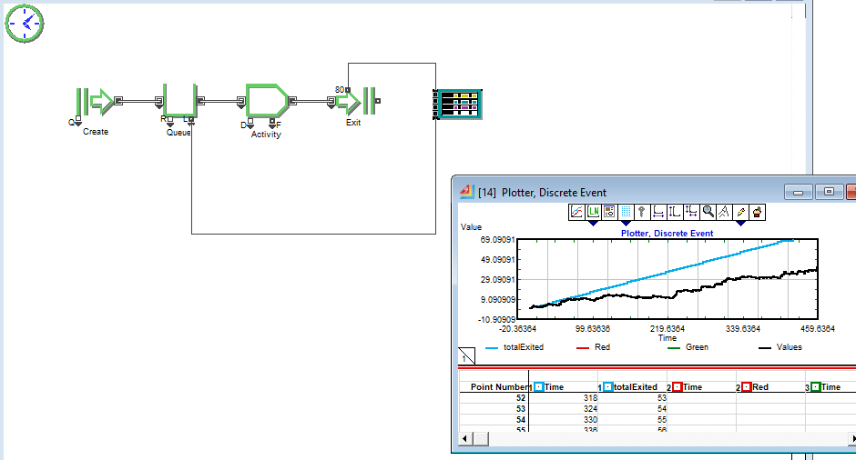
Graph with two counters
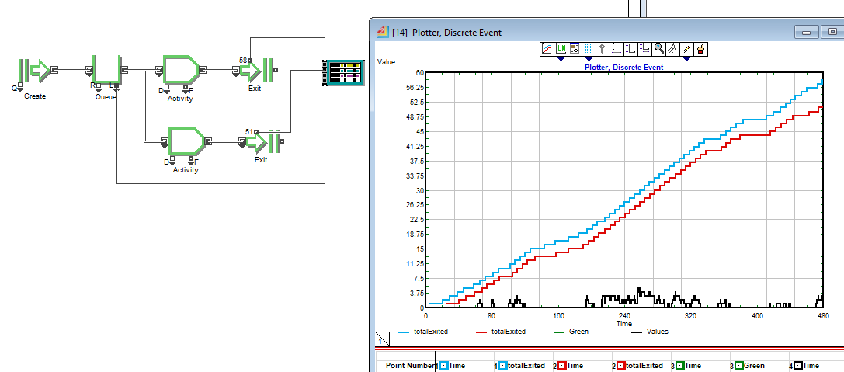
Output: (Printed results i.e. the plotter data)

Results with one counter:
- Queue
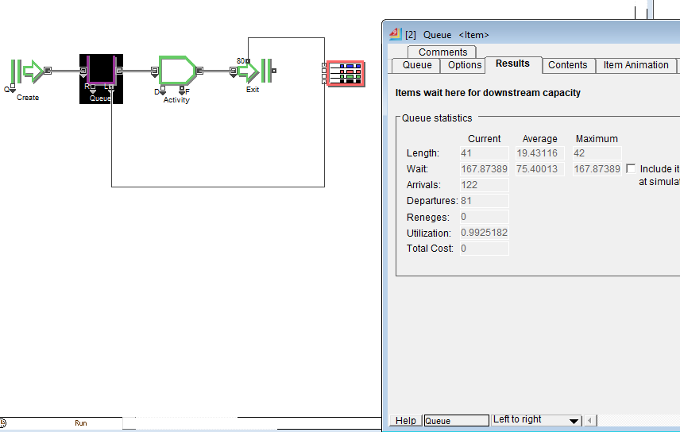
- Activity
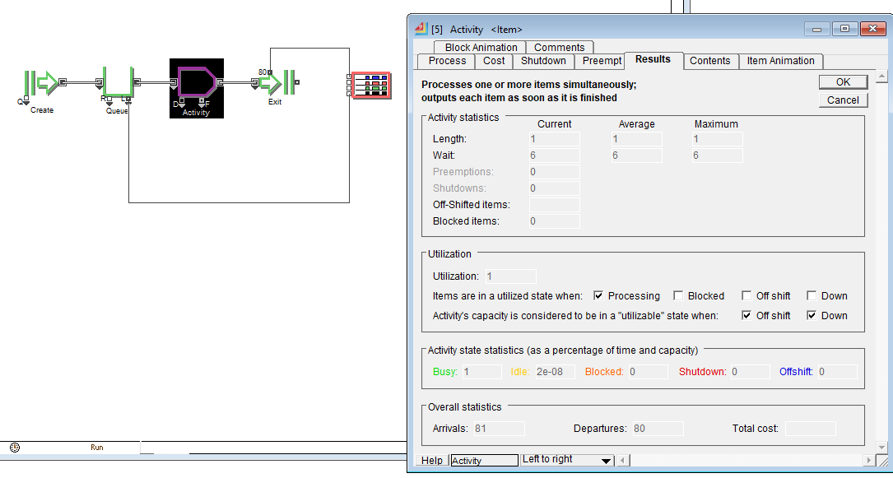
- Exit

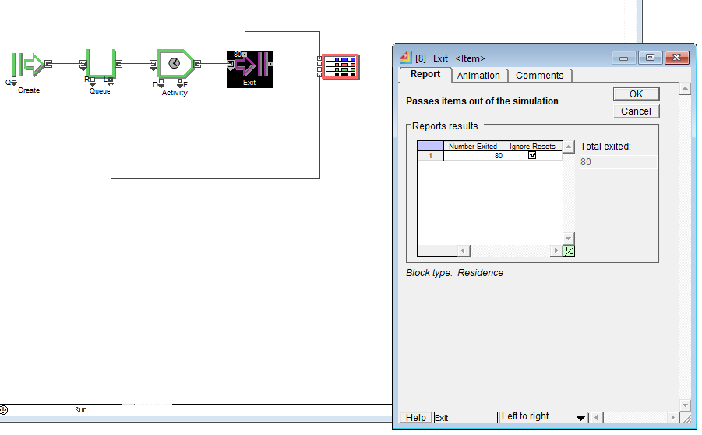
Results with 2 counters:
- Queue
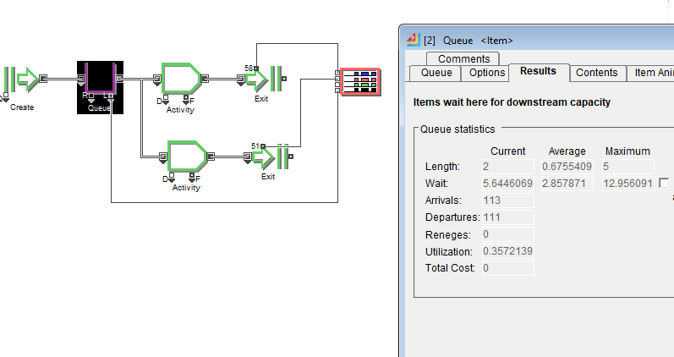
- Activity
  - Counter 1
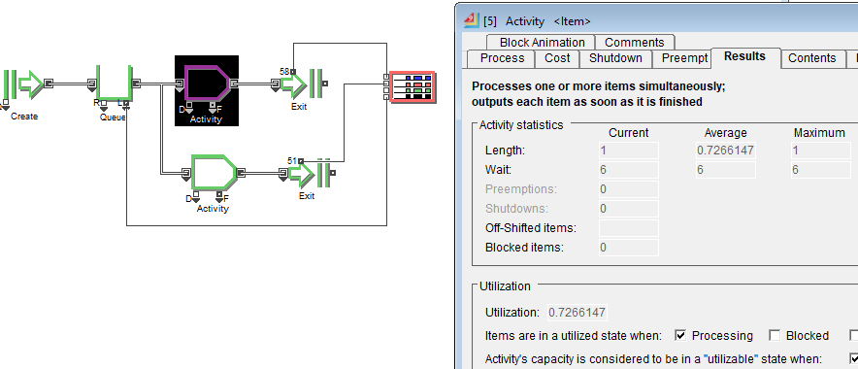
  - Counter 2
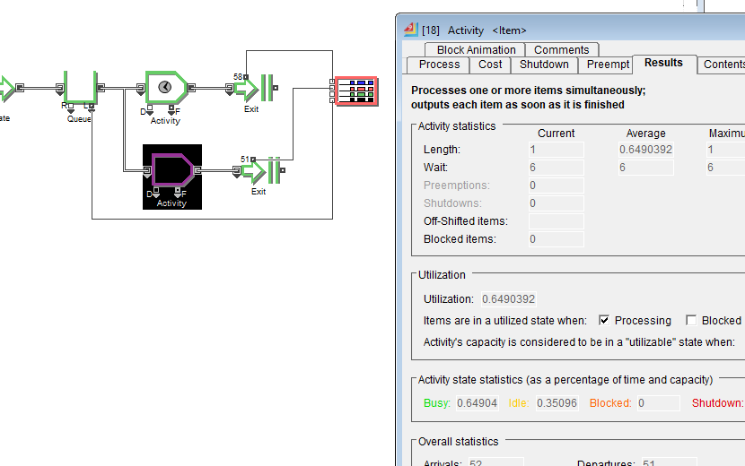

- Exit
  - Exit 1
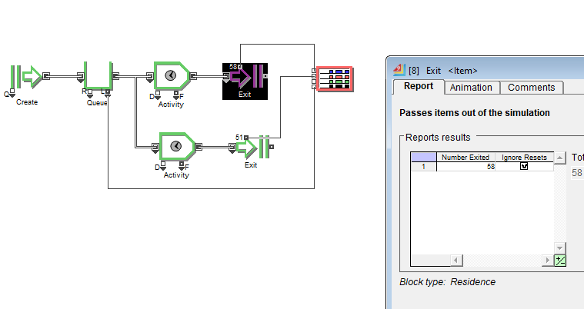
  - Exit 2
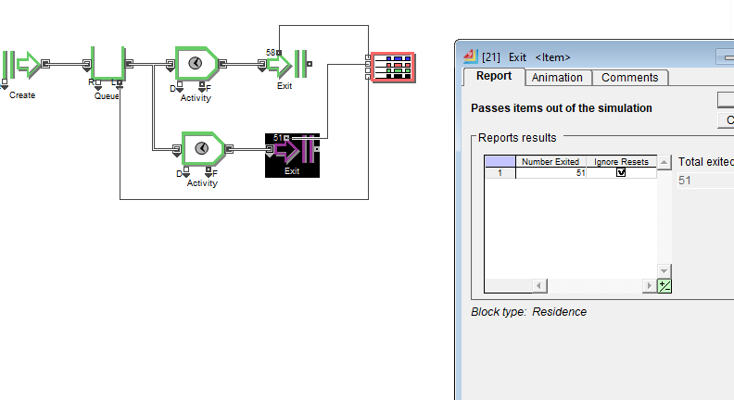
_________________________________________________________________________

Questions:

- List down the benefits of using a special purpose package such as Extend Sim to implement and run the simulation problem

- ExtendSim's hierarchy allows for unique identities for each block and permits block information to be used locally.
- Block reusability increases productivity, improves consistency of design, and avoids having to reinvent the wheel each time you build a new model.
- It is an easy-to-use, yet extremely powerful, tool for simulating processes. It helps understand complex systems and produce better results faster.

_____________________________________________________________________

Outcomes:

CO1 - Apply the experimental process of a simulation using spreadsheets as well as simulation language/package.

___________________________________________________________________________

Conclusion: We implemented the single channel Queuing model using Extend Sim and estimated system performance. Understood the benefits of using a special purpose software such as Extend Sim to implement and run the simulation problem as given.

Grade: AA / AB / BB / BC / CC / CD /DD

Signature of faculty in-charge with date
___________________________________________________________________________
References:

Books/ Journals/ Websites:

Text Book:

Banks J., Carson J. S., Nelson B. L., and Nicol D. M., “Discrete Event System Simulation”, 3rd edition, Pearson Education, 2001.

(Autonomous College Affiliated to University of Mumbai)
KJSCE/IT/TY B Tech/SEMVI/SM/2021-22

Additional Web Resources:

- Real Queuing Examples:http://www2.uwindsor.ca/hlynka/qreal.html
This site contains excerpts from news articlesthat deal with aspects of waiting lines.

- ClearQ:http://clearq.com/This company produces “take-a-number” systems for service facilities (e.g., delis), but also provides performance information about the waiting line.

- Qmatic:http://us.q-matic.com/index.htmlThiscompany produces informational displays and other products to keep customers informed about waiting times.

- “Queuing Presentation” by Richard Larson, given at the Institute for Operations Research and the

Management Sciences:http://caes.mit.edu/people/larson/MontrealINFORMS1/sld001.htm.
- The Queuing Theory

This site has two animated displays of waiting lines. The user can change arrival and service rates to see how performance is affected.

This Web site contains information about waiting lines as well as links to other interesting sites.

The Queuing ToolPak is an Excel add-in that allows you to easily compute performance measures for a number of different waiting line models

- Extend sim Manual

.

(Autonomous College Affiliated to University of Mumbai)

